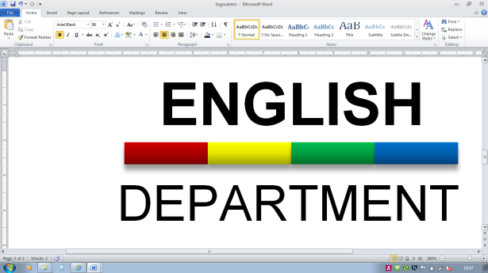

AQA A-Level English Language (7702)

Welcome to the A-level English Language course: essentially, this is *linguistics*. You are going to love it and learn so much about how and why we use language in the ways that we do. In order that you hit the ground running (to use a very clichéd idiomatic expression), complete these pre-course preparatory tasks.

**TASK 1: ISSUES IN CONTEMPORARY ENGLISH**

The first part of this task is to find two opinion articles about slang and young people. You will find the media often report on language issues and it’s good to familiarise yourself with how the English Language is spoken about/the attitudes that exist. Summarise the articles and identify the different attitudes/reasons given. You will be writing your own piece of opinion journalism about **one** of the following contemporary issues in modern British English:

1. Political correctness
2. Americanisms
3. Gender issues & sexism in our language
4. The impact of social media on language use

The second part of this task is to conduct some research into one of the above topics. Look beyond journalism and try to find some linguistic theory about these issues; locate some quotations and opinions about these topics. Keep a record of this reading & research – you will need to hand this in as evidence in September (either as hard copies and/or as a bibliography). For example, to get you started, you could research the Euphemism Treadmill – Stephen Pinker.

**TASK 2: WRITING A PIECE OF OPINION JOURNALISM**

Your third task is more tricky & demanding. You need to write a piece of opinion journalism about your chosen linguistic topic. It ought to be for a broadsheet publication & audience (e.g. The Times, The Guardian, The Telegraph, etc.) and approximately 500 words in length. Essentially, you are offering, exploring, explaining and justifying your opinion about the issue you have researched. Your article ought to include explicit references to your research and also consider a range different viewpoints.

The work you produce will need to be handed to your English Language teacher in your first lesson in September 2025. We look forward to reading what you produce.