**Sir William Robertson Academy Sixth Form Dress Code “Professional Business Dress”**

The aim of the Sixth Form dress code is to ensure students are dressed smartly and. As role models for younger students and ambassadors for our Academy it is important that Sixth Form students reflect our professionalism, high aspirations and desire for excellence in all that they do.

These images and descriptions below are to help you adhere to the expectations of professional, business dress and are by no means exhaustive. We expect you to use your judgment and look to Sir William Robertson Academy staff for guidance about what is appropriate.

Any concerns will be raised with individuals. We reserve the right to ask students to modify/change their dress if they do not meet the required expectations of professional business dress. The Head of Sixth Form’s decision is final.

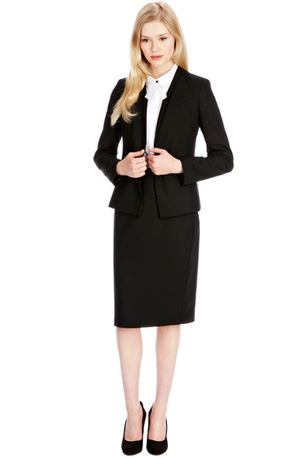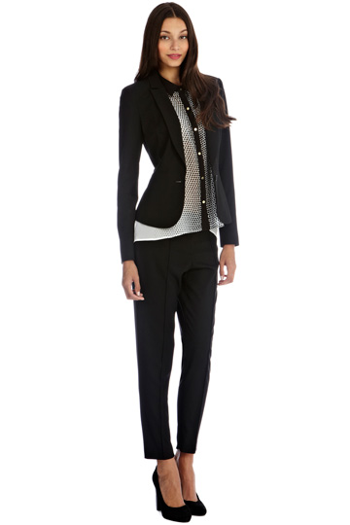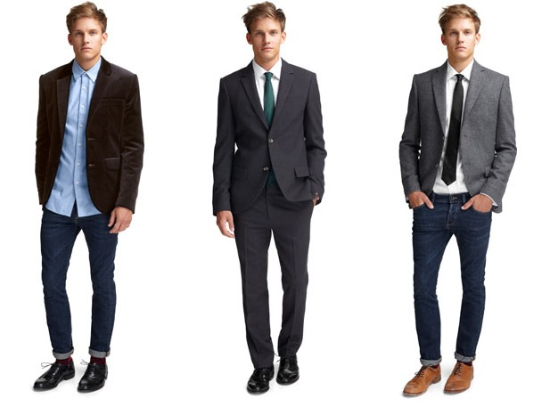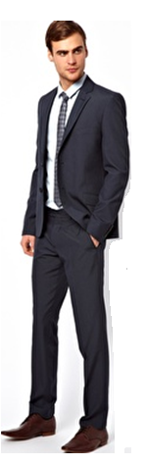

Items of clothing that are considered appropriate:

* Smart trousers, chinos, skirts or similar.
* Collared shirts, smart blouses or tops. Blazers are recommended.
* Smart, dark, polishable shoes. It is recommended that these are flat or low heeled for practicality.

Students should not wear denim or leather jackets, jeans, leggings, informal t-shirts or tops, clothes with large logos, tracksuit bottoms, hoodies or trainers. Hair, jewellery and nails should be in keeping with a professional workplace.

For further guidance, please speak to the Head of Sixth Form who will be happy to provide guidance and advice about items before they are purchased.